

DBMS PROJECT – CRIME DATABASE –

FINAL REPORT

SUBMITTED BY:

GROUP 3:

DEVANANDA A : ROLL NO 33

LIZONA LOY PARAYIL : ROLL NO 47

KRISHNAPRIYA R : ROLL NO 46

M S GAURI SANKAR : ROLL NO 48

NIDHIN K BIJU : ROLL NO 55

SUBMITTED TO:

Mrs.JOSNA V R

# INDEX

|  |  |  |
| --- | --- | --- |
| Sl no. | Content | Page no. |
| 1. | Functional  Requirements | 3 - 4 |
| 2. | E R Diagram | 5 |
| 3. | SQL Query | 6 - 7 |
| 4. | Procedure | 8 - 10 |
| 5. | Trigger | 11 - 12 |
| 6. | Tables | 13 - 15 |
| 7. | UI | 16 - 17 |
| 8. | Conclusion | 18 |

**GITHUB LINK:** [**https://github.com/Devananda-A/DB MS.git**](https://github.com/Devananda-A/DBMS.git)

**FUNCTIONAL REQUIREMENTS:**

## Scope

The system supports registering criminal profiles in the database. It allows updating criminal profiles whenever new information is available. Crimes can be recorded and linked directly to the criminals involved. Officers can be assigned to cases for proper investigation. Victim information can be recorded and managed. Witness statements can also be maintained in the system. The progress of each case is tracked from opening to closure. The system monitors criminal status, including whether the criminal is Arrested, Wanted, or Released.

## 1. Criminal Management

The system allows users to add criminal records into the database. Each criminal record includes a unique Criminal_ID for identification. The full name of the criminal is stored in the record. Age and gender of the criminal are maintained. The address of the criminal is recorded to help locate and contact them. The status of the criminal, which can be Arrested, Wanted, or Released, is tracked. A photograph of the criminal can be uploaded and associated with the record.

## 2. Crime Management

The system allows registering a new crime entry in the database. Each crime record has a unique Crime_ID to distinguish it from others. The type of crime, such as Theft, Assault, or Homicide, is stored. The date and time when the crime occurred are recorded. The location of the crime is maintained for investigation purposes. The severity level of the crime is indicated. A detailed description of the crime is stored to provide context for investigators.

## 3. Case Management

The system allows opening new cases and closing existing cases. Each case is assigned a unique Case_ID. Related Crime_IDs are linked to the case to indicate which crimes are under investigation. Criminal_IDs involved in the case are also associated with the case. An officer is assigned to the case using their Officer_ID. The status of the case can be Open, Closed, or On Hold. The start date of the case is recorded when it is opened. The end date of the case is recorded when it is closed.

## 4. Officer Management

The system maintains records for each officer. Each officer has a unique Officer_ID. The name of the officer is stored. The rank of the officer is recorded. Contact information for the officer is maintained. The police station assigned to the officer is recorded using Station_ID.

## 5. Station Management

The system stores information for each police station. Each station has a unique Station_ID. The name of the station is recorded. The location of the station is stored. The contact number for the station is maintained.

## 6. Victim Management

The system allows adding records of victims involved in crimes. Each victim has a unique Victim_ID. The full name of the victim is stored. The age and gender of the victim are recorded. The address of the victim is maintained. Contact information for the victim is stored. Victims are linked to the relevant cases in the system.

## 7. Witness Management

The system allows adding records for witnesses. Each witness has a unique Witness_ID. The full name of the witness is stored. The witness’s statement is recorded. Contact information for the witness is maintained. Witnesses are linked to the relevant cases in which they provided testimony.

## 8. Suspect Management

The system allows adding records for suspects. Each suspect has a unique AADHAAR number for identification. The full name of the suspect is recorded. The age and gender of the suspect are maintained. The address of the suspect is stored. The status of the suspect, which can be Guilty or Not Guilty, is tracked. A photograph of the suspect can be added to the record. Suspects are linked to the relevant crimes and cases.

**ER DIAGRAM:**

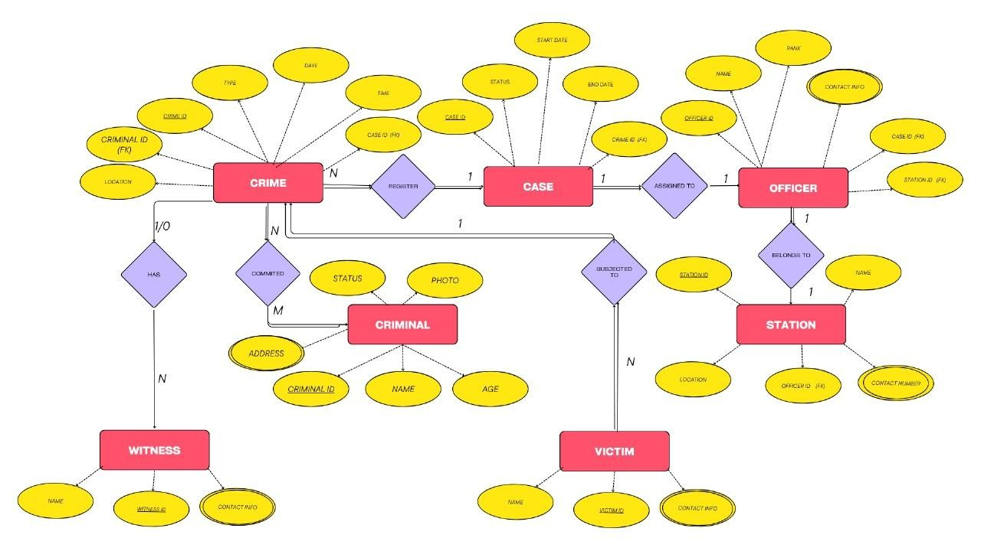

**SQL QUERY:**

(PROCEDURES,TRIGGERS,)

CREATE DATABASE IF NOT EXISTS crimedatabase;

USE crimedatabase;

CREATE TABLE IF NOT EXISTS Station ( station_id INT PRIMARY KEY AUTO_INCREMENT, station_name VARCHAR(100), location VARCHAR(150), phone VARCHAR(15)

);

CREATE TABLE IF NOT EXISTS Officer ( officer_id INT PRIMARY KEY AUTO_INCREMENT, officer_name VARCHAR(100), officer_rank VARCHAR(50), station_id INT, contact_no VARCHAR(15),

FOREIGN KEY (station_id) REFERENCES Station(station_id)

);

CREATE TABLE IF NOT EXISTS CaseFile ( case_id INT PRIMARY KEY AUTO_INCREMENT, case_title VARCHAR(150), case_type VARCHAR(100), date_reported DATE, status VARCHAR(30), officer_id INT,

FOREIGN KEY (officer_id) REFERENCES Officer(officer_id)

);

CREATE TABLE IF NOT EXISTS Crime ( crime_id INT PRIMARY KEY AUTO_INCREMENT,

case_id INT, crime_description TEXT, crime_date DATE, crime_location VARCHAR(150),

FOREIGN KEY (case_id) REFERENCES CaseFile(case_id)

);

CREATE TABLE IF NOT EXISTS Criminal ( criminal_id INT PRIMARY KEY AUTO_INCREMENT, name VARCHAR(100), gender VARCHAR(10), age INT, address VARCHAR(150),

crime_id INT,

FOREIGN KEY (crime_id) REFERENCES Crime(crime_id)

);

CREATE TABLE IF NOT EXISTS Victim ( victim_id INT PRIMARY KEY AUTO_INCREMENT, name VARCHAR(100), age INT, contact_no VARCHAR(15), address VARCHAR(150), case_id INT,

FOREIGN KEY (case_id) REFERENCES CaseFile(case_id)

);

CREATE TABLE IF NOT EXISTS Witness ( witness_id INT PRIMARY KEY AUTO_INCREMENT, name VARCHAR(100), contact_no VARCHAR(15), statement TEXT, case_id INT,

FOREIGN KEY (case_id) REFERENCES CaseFile(case_id)

);

CREATE TABLE IF NOT EXISTS Station_Log ( log_id INT PRIMARY KEY AUTO_INCREMENT,

officer_id INT, action VARCHAR(50), log_time DATETIME

);

CREATE TABLE IF NOT EXISTS Case_Log ( log_id INT PRIMARY KEY AUTO_INCREMENT,

case_id INT, old_status VARCHAR(30), new_status VARCHAR(30), updated_on DATETIME

);

CREATE TABLE IF NOT EXISTS Criminal_Log ( log_id INT PRIMARY KEY AUTO_INCREMENT,

criminal_id INT,

log_message VARCHAR(255), log_time DATETIME

);

**PROCEDURE:**

DELIMITER //

CREATE PROCEDURE AddCaseWithOfficer(

IN p_title VARCHAR(150),

IN p_type VARCHAR(100),

IN p_officer INT

)

BEGIN

INSERT INTO CaseFile(case_title, case_type, date_reported, status, officer_id) VALUES(p_title, p_type, CURDATE(), 'Open', p_officer);

SELECT * FROM CaseFile WHERE officer_id = p_officer ORDER BY case_id DESC LIMIT 3;

END //

DELIMITER ;

DELIMITER //

CREATE PROCEDURE RegisterCriminal(

IN p_name VARCHAR(100),

IN p_gender VARCHAR(10),

IN p_age INT,

IN p_address VARCHAR(150),

IN p_crime_id INT

)

BEGIN

INSERT INTO Criminal(name, gender, age, address, crime_id)

VALUES(p_name, p_gender, p_age, p_address, p_crime_id);

SELECT c.crime_id, c.crime_description, cf.case_title, cf.status

FROM Crime c

JOIN CaseFile cf ON cf.case_id = c.case_id

WHERE c.crime_id = p_crime_id;

END //

DELIMITER ;

DELIMITER //

CREATE PROCEDURE AddVictim(

IN p_name VARCHAR(100),

IN p_age INT,

IN p_contact VARCHAR(15),

IN p_address VARCHAR(150),

IN p_case INT

)

BEGIN

INSERT INTO Victim(name, age, contact_no, address, case_id)

VALUES(p_name, p_age, p_contact, p_address, p_case);

SELECT name, contact_no FROM Victim WHERE case_id = p_case;

END //

DELIMITER ;

DELIMITER //

CREATE PROCEDURE CloseCase(IN p_case INT)

BEGIN

UPDATE CaseFile SET status = 'Closed' WHERE case_id = p_case;

SELECT cf.case_id, cf.case_title, cf.status, o.officer_name

FROM CaseFile cf

JOIN Officer o ON cf.officer_id = o.officer_id

WHERE cf.case_id = p_case;

END //

DELIMITER ;

DELIMITER //

CREATE PROCEDURE GetOfficerCases(IN p_officer_id INT)

BEGIN

SELECT cf.case_id, cf.case_title, cf.case_type, cf.status, cf.date_reported

FROM CaseFile cf

WHERE cf.officer_id = p_officer_id

ORDER BY cf.date_reported DESC;

END //

CREATE PROCEDURE UpdateCaseStatus(IN p_case_id INT, IN p_new_status VARCHAR(30)) BEGIN

UPDATE CaseFile

SET status = p_new_status

WHERE case_id = p_case_id;

SELECT case_id, case_title, status

FROM CaseFile

WHERE case_id = p_case_id;

END //

CREATE PROCEDURE DeleteCriminalRecord(IN p_criminal_id INT)

BEGIN

DECLARE v_case_status VARCHAR(30);

SELECT cf.status INTO v_case_status

FROM Criminal cr

JOIN Crime c ON cr.crime_id = c.crime_id

JOIN CaseFile cf ON c.case_id = cf.case_id

WHERE cr.criminal_id = p_criminal_id;

IF v_case_status = 'Closed' THEN

DELETE FROM Criminal WHERE criminal_id = p_criminal_id;

SELECT CONCAT('Criminal ID ', p_criminal_id, ' deleted successfully') AS Message; ELSE

SELECT 'Cannot delete criminal record until case is closed' AS Message;

END IF;

END //

CREATE PROCEDURE SearchCrimeByDate(IN p_start DATE, IN p_end DATE)

BEGIN

SELECT c.crime_id, c.crime_description, c.crime_date, cf.case_title, o.officer_name

FROM Crime c

JOIN CaseFile cf ON c.case_id = cf.case_id JOIN Officer o ON cf.officer_id = o.officer_id

WHERE c.crime_date BETWEEN p_start AND p_end

ORDER BY c.crime_date;

END //

CREATE PROCEDURE GetCriminalHistory(IN p_criminal_id INT)

BEGIN

SELECT cr.name AS Criminal_Name, cr.gender, cr.age, cr.address, c.crime_description, cf.case_title, cf.status, o.officer_name

FROM Criminal cr

JOIN Crime c ON cr.crime_id = c.crime_id

JOIN CaseFile cf ON c.case_id = cf.case_id JOIN Officer o ON cf.officer_id = o.officer_id

WHERE cr.criminal_id = p_criminal_id;

END //

CREATE PROCEDURE VictimReport()

BEGIN

SELECT v.victim_id, v.name AS Victim_Name, v.age, v.contact_no, cf.case_title, cf.status FROM Victim v

JOIN CaseFile cf ON v.case_id = cf.case_id

ORDER BY cf.case_id;

END //

**TRIGGER:**

DELIMITER //

CREATE TRIGGER AfterOfficerInsert

AFTER INSERT ON Officer

FOR EACH ROW

BEGIN

INSERT INTO Station_Log(officer_id, action, log_time)

VALUES(NEW.officer_id, 'New Officer Added', NOW());

END //

DELIMITER ;

DELIMITER //

CREATE TRIGGER AfterCaseUpdate

AFTER UPDATE ON CaseFile

FOR EACH ROW

BEGIN

IF OLD.status <> NEW.status THEN

INSERT INTO Case_Log(case_id, old_status, new_status, updated_on)

VALUES(NEW.case_id, OLD.status, NEW.status, NOW());

END IF;

END //

DELIMITER ;

DELIMITER //

CREATE TRIGGER AfterCriminalInsert

AFTER INSERT ON Criminal

FOR EACH ROW

BEGIN

INSERT INTO Criminal_Log(criminal_id, log_message, log_time)

VALUES(NEW.criminal_id, CONCAT('Criminal Added: ', NEW.name), NOW());

END //

DELIMITER ;

CREATE TRIGGER BeforeCriminalDelete

BEFORE DELETE ON Criminal

FOR EACH ROW

BEGIN

DECLARE v_status VARCHAR(30);

SELECT cf.status INTO v_status

FROM Crime c

JOIN CaseFile cf ON c.case_id = cf.case_id

WHERE c.crime_id = OLD.crime_id;

IF v_status <> 'Closed' THEN

SIGNAL SQLSTATE '45000'

SET MESSAGE_TEXT = 'Cannot delete criminal record until case is closed.';

END IF;

END //

CREATE TRIGGER AfterCaseInsert

AFTER INSERT ON CaseFile

FOR EACH ROW

BEGIN

INSERT INTO Case_Log(case_id, old_status, new_status, updated_on)

VALUES(NEW.case_id, NULL, NEW.status, NOW());

END //

CREATE TRIGGER AfterVictimInsert

AFTER INSERT ON Victim

FOR EACH ROW

BEGIN

INSERT INTO Case_Log(case_id, old_status, new_status, updated_on)

VALUES(NEW.case_id, 'Victim Added', 'Victim Added', NOW());

END //

CREATE TRIGGER BeforeCaseUpdate

BEFORE UPDATE ON CaseFile

FOR EACH ROW

BEGIN

IF OLD.status = 'Closed' AND NEW.status = 'Open' THEN

SIGNAL SQLSTATE '45000'

SET MESSAGE_TEXT = 'Cannot reopen a closed case.';

END IF;

END //

DELIMITER ;

10 SQL QUERIES:

**1. CREATE DATABASE IF NOT EXISTS CrimeDatabase;**

**USE CrimeDatabase;**

**CREATE TABLE Officer (**

**officer_id INT PRIMARY KEY AUTO_INCREMENT,**

**officer_name VARCHAR(100),**

**officer_rank VARCHAR(50),**

**station_id INT,**

**contact_no VARCHAR(15)**

**);**

2.INSERT INTO Officer (officer_name, officer_rank, station_id, contact_no)

VALUES ('Arun Kumar', 'Inspector', 101, '9876543210');

3.ALTER TABLE Officer

ADD email VARCHAR(100);

4.SELECT o.officer_name, c.case_title, c.status

FROM Officer o

JOIN CaseFile c ON o.officer_id = c.officer_id;

5. UPDATE CaseFile

SET status = 'Closed'

WHERE case_id = 1;

6. DELETE FROM Criminal

WHERE criminal_id = 1;

7. DROP TABLE IF EXISTS CaseFile;

8. SELECT officer_id, COUNT(case_id) AS total_cases

FROM CaseFile

GROUP BY officer_id;

9. TRUNCATE TABLE CaseFile;

10. RENAME TABLE CaseFile TO Cases;

**TABLES:**

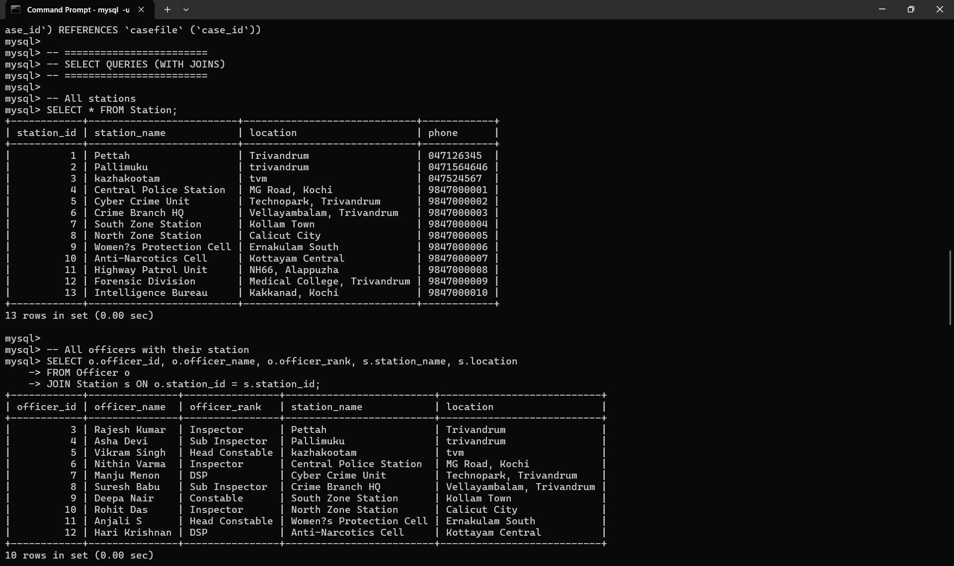

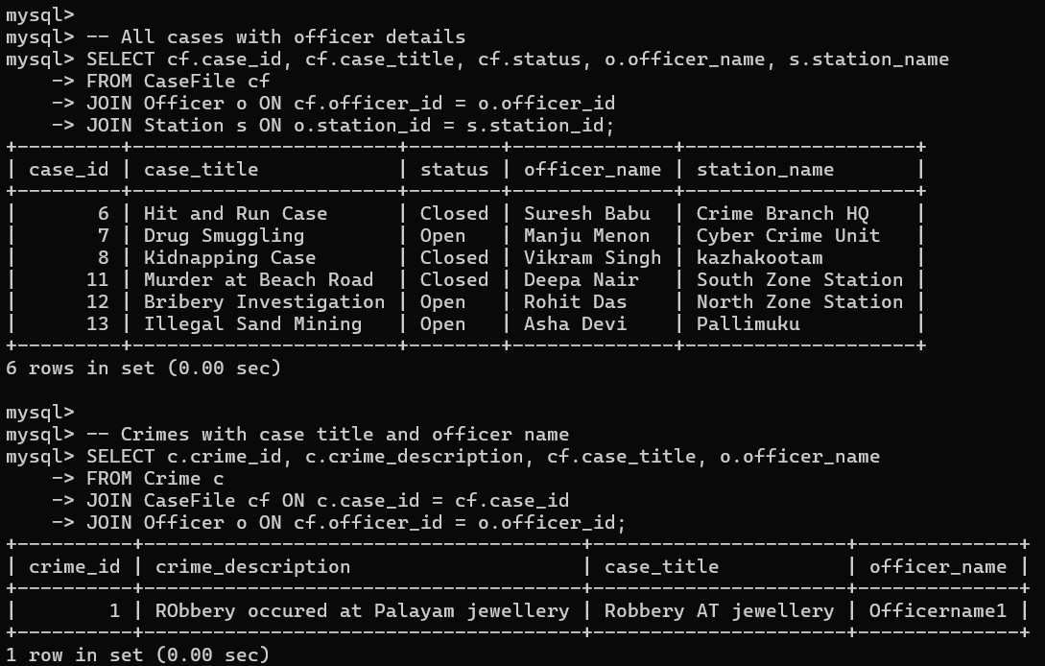

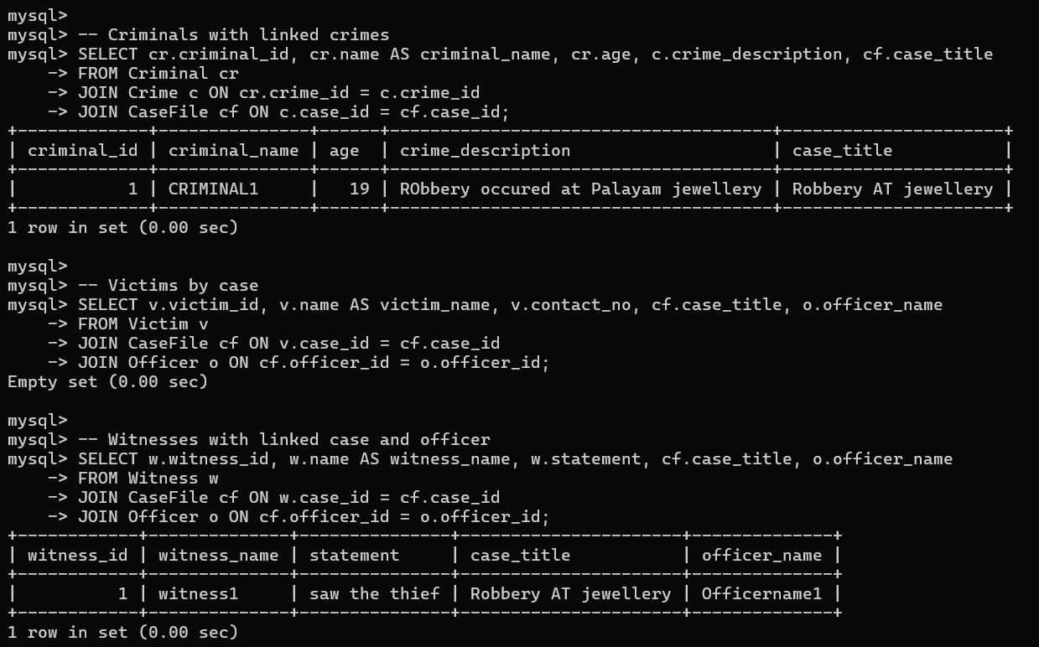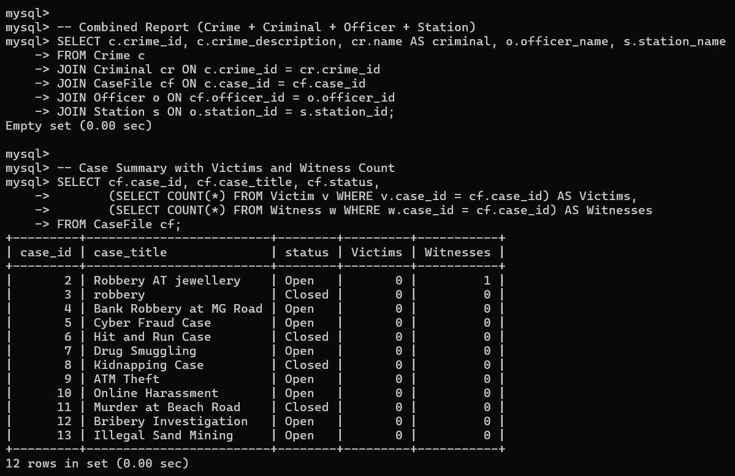

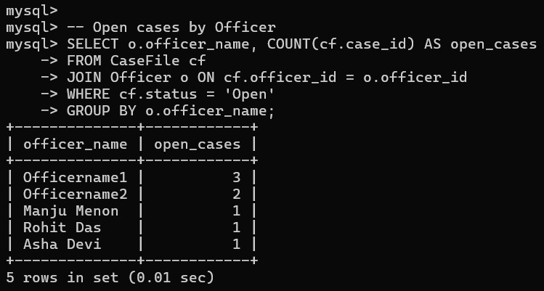

UI:

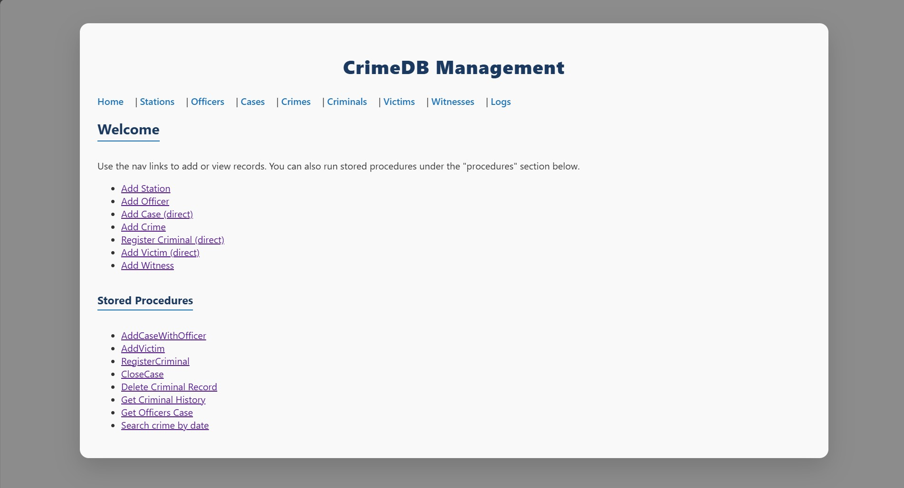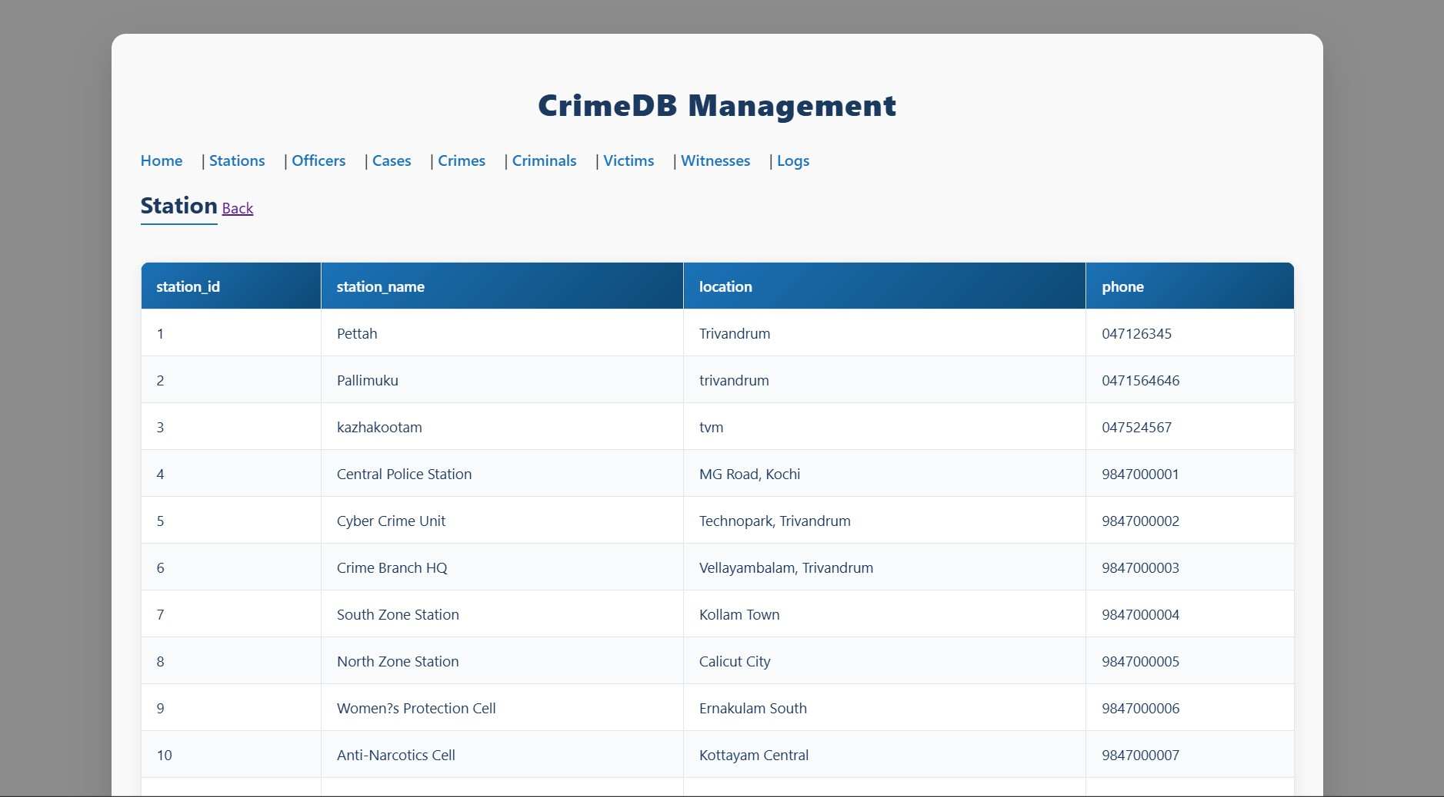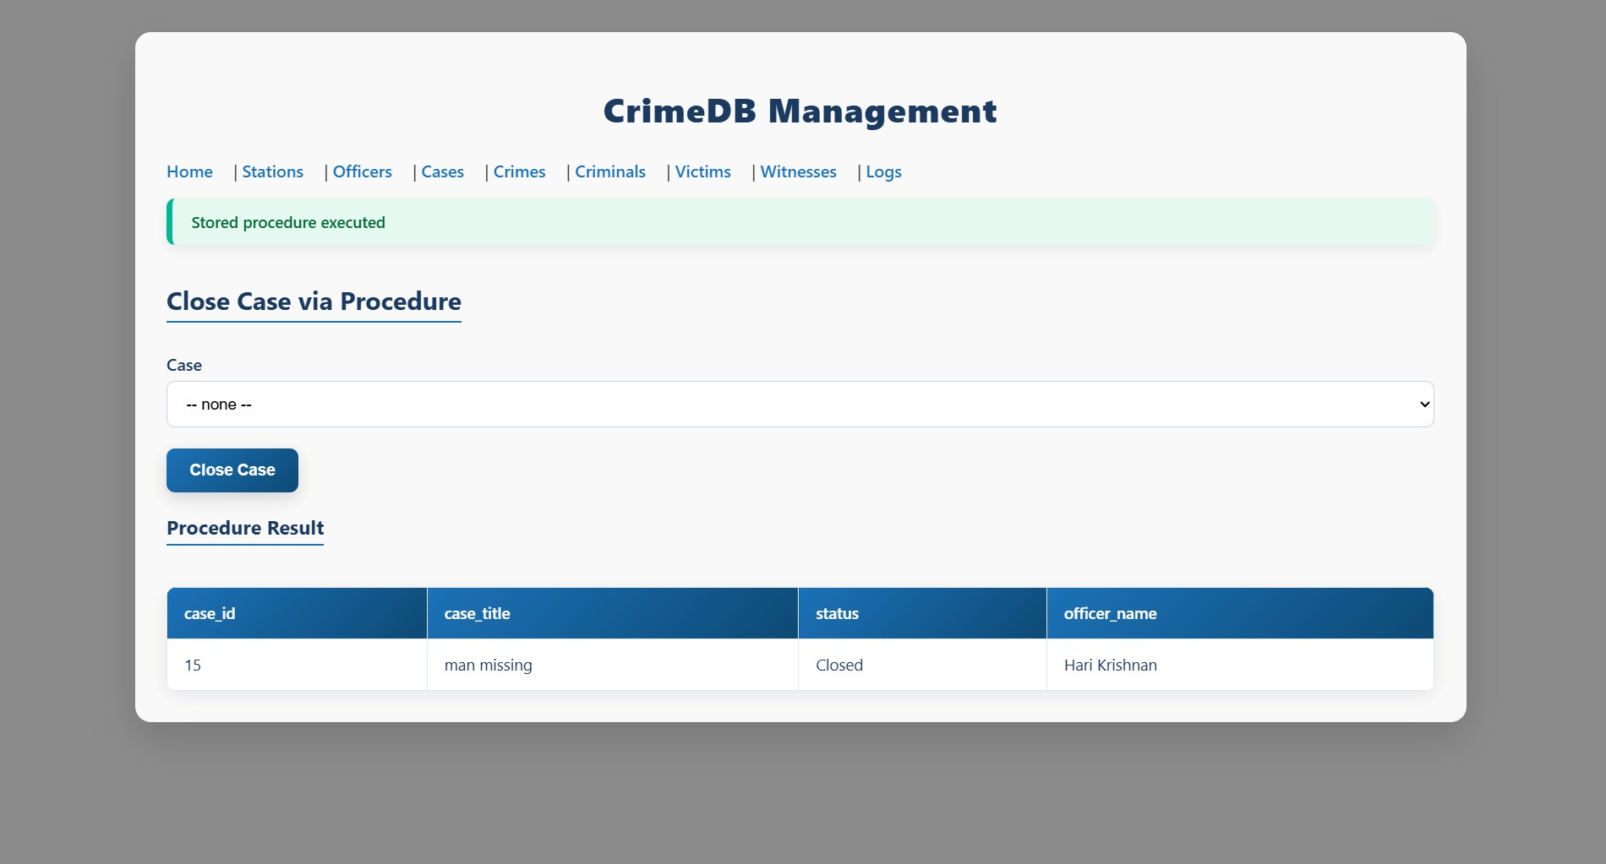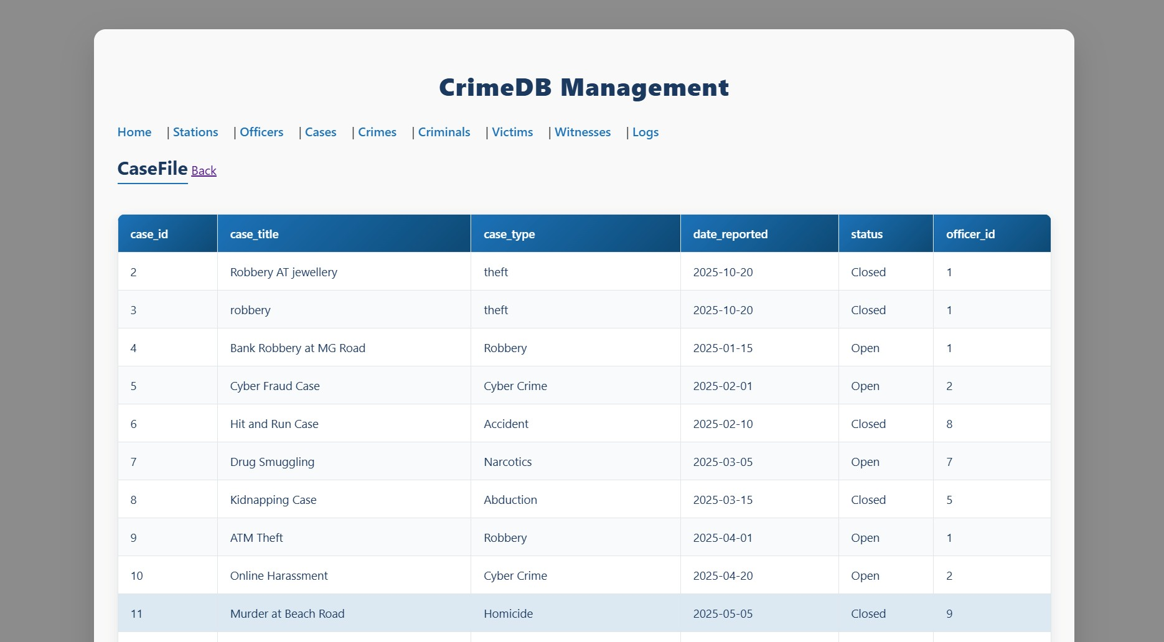

**CONCLUSION:**

The Crime Database Management System is an efficient and structured solution for storing and managing criminal, case, and officer information. It ensures data consistency, accuracy, and security through the use of SQL queries, stored procedures, and triggers. The system automates key operations like case updates and report generation, reducing manual effort and errors. By applying proper database design and relational modeling, it supports quick data retrieval and reliable performance. Overall, it serves as a practical and scalable tool that enhances crime tracking, transparency, and decision-making for law enforcement agencies.